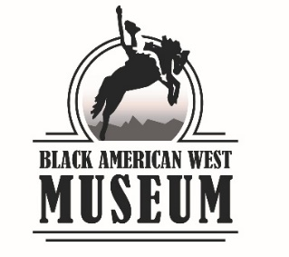

# **DEACCESSION AND DISPOSITION**

Museum Accession Number:

Item Name:

Description:

Recommended By (name and title):

Date presented to Board:

Rationale for Deaccession:

Rationale for Disposition:

Any notes from staff, volunteer, or Board discussion:

1. Criteria met for Deaccession (check all that apply):

The item does not pertain to the BAWMHC:

mission statement

acquisition policy

collecting plans

Lacks historical or museological value or usefulness:

lacks integrity, including if heavily reconstructed

lacks identity

lacks provenance

lacks authenticity

Cannot be salvaged even with prudent conservation care because of deterioration

Other:

Degree of conservation care necessary to maintain historic value of item is beyond the scope of the BAWMHC’s mission statement.

Item poses threat to the safety of the public, staff, or other collections items (examples: nitrate film, photo chemicals, kerosene gasoline, bombs, hand grenades, mace).

Item is a duplicate of other collections items, or is a typical duplicate of other items, which equally or better demonstrate an historical theme (examples: numerous similar costumes from the same decade, excessive copies of business directories, history books beyond future replacement expectations).

In compliance with federal or state law: ________________________________________________________

1. Disposition Recommendation:

Transfer to another non-profit educational institution or cultural organization

Transfer to regional, state, or local surplus

Retain for conservation research

Retain for educational programming

Public auction

Destroy

Other means, as determined appropriate by the Chair:

Optional Attachments:

Documentation concerning BAWMHC acquisition and ownership

Curatorial examination (include valuation)

Conservation examination

Documentation pertaining to federal or state law

Other relevant material

Approved

Date

Board Chair Signature

Board Chair Printed Name