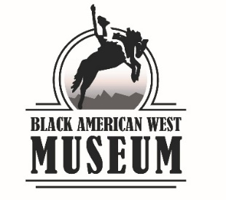

# **Deed of gift**

Museum Accession Number (FOR STAFF):

Name:

Address:

City, State, Zip:

Email:

Phone:

Description of Property:

Value:

Donor Credit Line:

□ The donor prefers to remain anonymous (please check if yes)

The owner, hereafter referred to as the “Donor” of the property described above, in consideration of the Donor’s interest in and for the work done by the Black American West Museum & Heritage Center to foster and promote the preservation and interpretation of artistic and historic objects in and for the Museum and its visitors, hereby gives, transfers, assigns, and delivers all of the Donor’s right, title, and interest in and to the property described above, excluding copyrights which the Donor may possess in said property, to the Black American West Museum & Heritage Center as an unrestricted gift.

The Internal Revenue Service Code requires that the Black American West Museum & Heritage Center substantiate and acknowledge donations with a value of $250 or more. If your donation falls in this category, please retain this deed with your permanent tax records. The Black American West Museum & Heritage Center also confirms that it did not provide you with any goods or services in exchange for your donation. Please file Form 8283 with your federal tax return for gifts with a value of $500 or greater if you intend to take a tax deduction for your gift.

Date

Donor(s) Signature

Donor(s) Printed Name

Date

Board Chairman