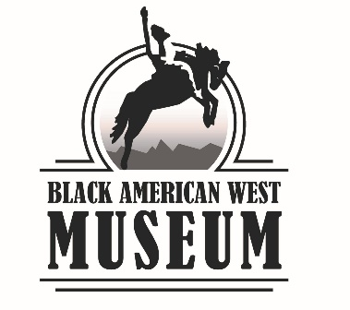

# **TRANSFER AGREEMENT**

Museum Accession Number:

Item Name:

Description:

Board Chair Signed Disposition Approval Date:

Transfer Date:

Receiving Institution Name:

Address:

City, State, Zip:

Email:

Phone:

Property transferred to the Receiving Institution as described above becomes the full legal property of Receiving Institution upon the Transfer Date listed above. Objects may have been treated with pesticides and other potentially toxic substances for purposes of conservation and preservation. Handling or use of without proper safeguards and precautions may cause the borrower to come into contact with these substances. The borrower and any individuals authorized by the borrower to use or handle this material hereby assume the risk of any injury, harm, or illness, and releases DMNS from liability.

This agreement may be executed in counterparts. Each counterpart when so executed shall be deemed to be an original and all of which together shall constitute one and the same agreement. The parties agree that faxed or scanned signatures shall be legally binding and of the same force and effect as original signatures.

By affixing their signature to this document, the Receiving Institution acknowledges transfer of objects described and they have read and agrees to the conditions listed above.

Transferred by:

Date

Signature

Printed Name

Received by:

Date

Signature

Printed Name